Purchasing Department
P.O. Box 13145 • Roanoke, VA 24031 PHONE (540) 853-1348
FAX (540) 853-2836

July 29, 2022

IFB 3090

RUFFNER PROFESSIONAL DEVELOPMENT AND OPERATIONS CENTER REPURPOSING SERVICES

Addendum #5

This addendum provides answers to questions received from contractors as of July 28, 2022 and includes a specification for the condensate hood in the Culinary Arts Kitchen, and the following revised electrical sheets:

E501, E502, E503, E506, E507, & E508

The bid closing date and time has been revised to Thursday, August 18th, 2022 at 3:00 PM. The deadline for questions has been extended until 5:00 PM on Tuesday, August 9th, 2022.

Questions & Answers:
Q1: Reference IFB project start dates- Several sections of the invitation including III. Scope of work and the bid form indicate a start date of August 1, 2022. Bids are due on Thursday, August 4, 2022. The project cannot start before the bids close. Please clarify.

A1: The Work shall begin after the contract has been awarded within 30 days of August 22, 2022.

Q2: Reference specification section 011000-2 1.04 WORK BY OWNER. Please clarify requirements

A2: Section “A” was deleted in its entirety by Addendum #4. Section “B” was revised by Addendum #4. Section “D” should be revised to read:

- Owner will supply, and contractor install the following:
  - Data Head ends, Data Switches, and Access points.
  - Owner will do all necessary administration to access points and data head ends and switches.
    - Note: Any servers that contractors need to install should be coordinated and approved with the IT department before implementation.
  - Security cameras are to be contractor furnished; contractor installed. Reference specification section 28 2000 “Video Surveillance”

Q3: Is this project Wage Scale Project?

A3: Yes, this project uses Federal funds. Compliance with the Davis Bacon Act is required. Refer to attachment 3 in the IFB.

Q4: Will the project completion dates be moved out further or will this still need to be complete August 2023?

A4: Currently there is no intention to extend the completion date.

Q5: Reference sheet P5.1 Detail - Water Heater. The detail calls for Aquastat to control HWRP associated with HWH-1. No equipment schedule provided for the HWRP? Is one required on any of the Water Heating Systems?

A5: The HWRP was added to the equipment schedule via Addendum 3. See Sheet P1.0. The only water heater that has a recirculating loop is HWH-5 located in Building 3.

Q6: The revised structural plans have not clouded the changes. What has been revised on the plans?

A6: There were no revisions to the plan sheets. The sheets included were part of a review set and not sealed & signed. The sheets included with addendum #3 have been sealed and signed and the “Not for Construction” note in the title block has been removed.

Q7: AD1.2 is missing from the set of plans.

A7: Sheet AD1.2 is included with this addendum.

Q8: Were the equipment screens shown on A1.4 purchased with the Trane package?

A8: No, Equipment screens are to be provided and installed by the successful bidder.

Q9: I’m going through the new drawings and have a question. There are several lighting fixtures located on the side of the building with no type listed. Are these existing to remain with a new circuit or are they new fixtures without a type listed. E-201 and E-202. They are on the exterior of the building all around. It shows a circuit listed but not a type. Please advise whether these fixtures are new or existing. If new, need to know fixture types.

A9: Fixtures not indicated with a “type” are existing to remain. These are all wall sconces.

Q10: There are (8) panels that are listed on the one-line that are not shown in the panel schedule. They are listed below.
- H-HVAC
- H-CTC1
- H-KTCH
- L-IPS
- STORAGE 1
- STORAGE 2
- M-3(SECTION 2)

A10: See attached revised electrical sheets E501, 502, 503, 506, 507, & 508. Clarifications:

- H-HVAC – Panel has been removed from the project.
- H-CTC1 – Panel has been removed from the project.
- H-KTCH – This should be high voltage kitchen panel HK in the kitchen. It feeds rooftop equipment.
- L-IPS – Name has been changed to LG1. Panel located in the electrical room on the first floor.
- STORAGE 1 – will be Located 45’ from Building 3 on the site
- STORAGE 2 – will be Located approximately 100’ from Building 3 on the site.
  - Note Panels Storage 1 &2 have been adjusted to be fed from the ECAR panel which is located near the car chargers. These panels and feeders are to be provided under separate contract. Only breakers in ECAR and raceway are part of this contract.
- M-3(SECTION 2) – Panel has been removed from the project.

Q11: Is there a site electrical drawing? The reason I ask is there is a panel for charging stations, but none are shown on our drawings. The panel schedule shows (14) of these at 100 amps each.

A11: There is no site electrical plan. New panel and equipment locations are shown on revised sheet C0-8 which was included with Addendum #3. The charging stations are to be provided and installed under separate contract. The intent of the plans is to have power available at the locations shown.

Q12: There are (2) storage buildings that we don’t know where they are located.

A12: The location of the storage buildings is shown on the revised Civil sheets included with Addendum #3. The intent of the plans is to have power available for future panels located in those buildings. Contractor to provide new underground raceway from panel ECAR to each building sized appropriately for the sub panel indicated and turned up within the building footprint.

Q13: E-503 has a schedule for Panel L-G1, E-501, E-301, and E-401 does not show a location for this panel. Please advise.

A13: See attached revised electrical sheets E501, 502, 503, 506, 507, & 508. All references to existing panel L-IPS shall be changed to panel LG-1

Q14: E501 Where is Panel M3 located?

A14: Panel M3 is located beside Panel LTG-2 in the second-floor electrical room.

Q15: C08 says to provide panel transformer and disc. What is required here as I don’t see it on riser or electrical drawings.

A15: The disconnect, panel, and transformer are the ECAR disconnect, panel, and transformer.
The indicated lot will contain multiple EV charging stations. The contractor is to provide and install this disconnect, panel, and transformer located near the storage buildings and EV lot as shown on sheet C-08.

Q16: C08 says to provide EVC’s? I’m assuming this is a vehicle charger? Can a spec be provided as to what is required?

A16: Yes, an EVC is an “Electric Vehicle Charger” See responses to Questions 11 & 15 above. EVC are provided and installed under separate contract. Only breakers in panel ECAR are provided. Panel and transformer for Panel ECAR are shown on the revised one-line diagram and schedule in revised electrical sheets included with this addendum.

Q17: C08 the 2” for future solar canopy show stopping at the corner of the parking lot. Is this correct?

A17: Yes, this is correct. The new raceways are for a future canopy provided and installed under separate contract.

Q18: E501-E507 No Panel schedules for Storage Building #1 and Storage Building #2

A18: Storage Building Panels are both 100-amp, single phase panels, with 100 amp 2 pole main breaker and 10 spare 20 amp breakers. These panels and feeders are to be provided under separate contract. See response to questions 10 and 16 above. Refer to revised sheet E501 included with this addendum.

Q19: E302 and E402 do not show the same electrical gear in the same locations. Which is correct?

A19: Sheet E402 has the correct locations.

Q20: E501-E507 No panel schedule for H-KTCH

A20: See attached revised electrical sheet E506 for panel schedule.

Q21: E404 HVAC Teaching Lab 210B multiple circuits from panels HWLD2, LHVAC2, and LHVAC1. Nothing is filled out on drawings or panel schedules for all of the equipment in this room. Please provide circuit and disconnect info.

A21: See attached revised electrical sheets E501, 502, 503, 506, 507, & 508.

Q22: In the new drawings there is a bunch of mechanical equipment in the training room. The circuits they have listed for the equipment doesn’t match the panel schedule so we don’t know what is required. For example, the mini split units shown have circuits LHVAC2-2 and LHVAC2-6. On the panel schedule both of those circuits are listed as spares. It’s the same issue with the other equipment that is shown to be in panel LHVAC1. Please advise.

A22: See attached revised electrical sheets E501, 502, 503, 506, 507, & 508. Panel schedules have been updated to show equipment. The following panels were updated for missing circuits – HK, LDP3, LG1, LHVAC1, LHVAC2, HWLD1, HWLD2, LWLD1, LWLD2, M2, and LDP1.

Q23: 11400, kitchen. I hope it’s not too late to ask but we haven’t received anything about the Condensate Hood #14 for the Dish Room. It was not included in the Kitchen Hood Package, so it was never seen by CaptiveaAire. It is listed on the spec sheet and drawing but it was never given a proper spec sheet for the hood itself. Do you know anything about this or know where I can look this information up so I can send it to CaptiveAire asap?

A23: Condensate Hood Specification included with this addendum. Note: "The hood is 4'-0" sq x 2'-0" high. It exhausts at 150CFM/ft, so at 4' in length it exhausts 600 cfm as listed on the equipment schedule."

Q24: We need information about the Condensate Hood #14 for this Dish Room. It is listed on the Spec sheet and drawing but it was never given a proper Spec sheet for the hood itself.

A24: See response to question #23 above.

Q25: Telephone Inquiry – Reference Addendum #3 Page 1 “Omit Specification sections 271500 “Horizontal Cabling & 280528 “Security Pathways”. Is the data and network scope being removed from the project and being handled by the owner?

A25: No, the scope of work is not being removed. Specification section "123616 Metal Countertops" has been removed from the Table of Contents (TOC) and the section itself removed. The work is covered under other specification sections.

Sections 271500 and 280528 are only removed from the TOC. These sections were in the DD submittal but then not included in the final construction docs. They were inadvertently left in the TOC. Addendum 3 reflects the removal of the reference to these sections from the TOC.

Reference spec section 271513 - COMMUNICATIONS COPPER HORIZONTAL CABLING in in the specifications which is a replacement for 271500. 280528 - SECURITY PATHWAYS was removed, and the requirements are addressed in other spec sections.

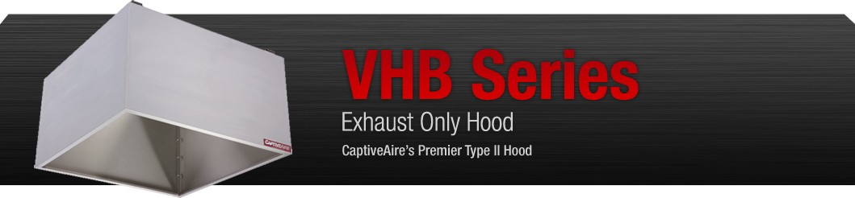

The VHB Series is CaptiveAire's Premier Type II, Exhaust Only hood to be used over equipment not producing grease laden vapors. Type II hoods are used for condensation or heat removal applications.

Advantages

Exhaust Flow Rates: Superior exhaust flow rates.
Construction: Single wall type hood fabricated of Type 304 stainless steel, #3 or #4 polish, on all exposed surfaces when used in condensate applications. Type 430 stainless steel, #3 or #4 polish available when used for heat applications. Pre­punched hanging angles on each end of hood. Additional set provided for hoods longer than 12'.
Condensate Applications: Integral 4­sided perimeter gutter and one drain standard for high­moisture exhaust.
Reduced Lead Times and Shipping Costs: Produced on a high volume assembly line at one of five manufacturing facilities to reduce lead times and shipping costs.
Optional REM Construction: Two options available when removable condensation baffles are required for heavy condensate applications. Designs available for one baffle or two baffle configuration to collect and drain condensation into gutter.
Optional Double Wall Construction: Double wall front used when switches are needed on the face of the hood and/or lights are desired. Mechanical baffle provides a built­in wiring chase for optimal positioning of electrical controls and outlets on the front face of the hood.
Optional Lights: Incandescent, LED and fluorescent lights are available.
Optional Make­Up Air: Make­up air can be supplied through optional front and/or side plenums (PSP Accessory).
Optional Enclosure Panels: Constructed of stainless steel. Sized to extend from hood top to ceiling, enclosing pipe and hanging parts.

Performance

CONFIGURATION | LIGHT LOAD EXHAUST CFM / FT. | HEAVY LOAD EXHAUST CFM / FT.
Wall & 1­piece island | 100 | 150
Recommended Duct Sizing: Exhaust ­ Based on 800 FPM

Features
VHB Model

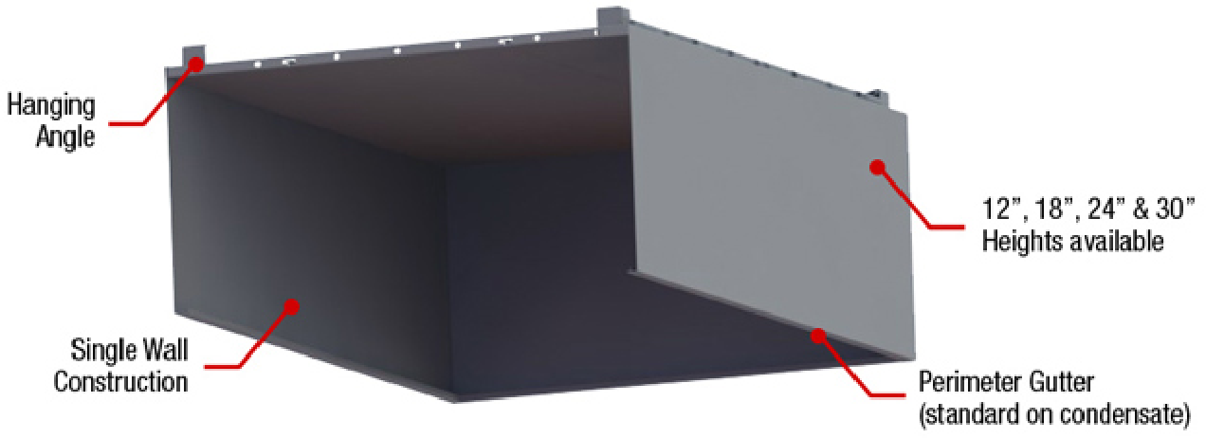

VHB Model with One REM Baffle

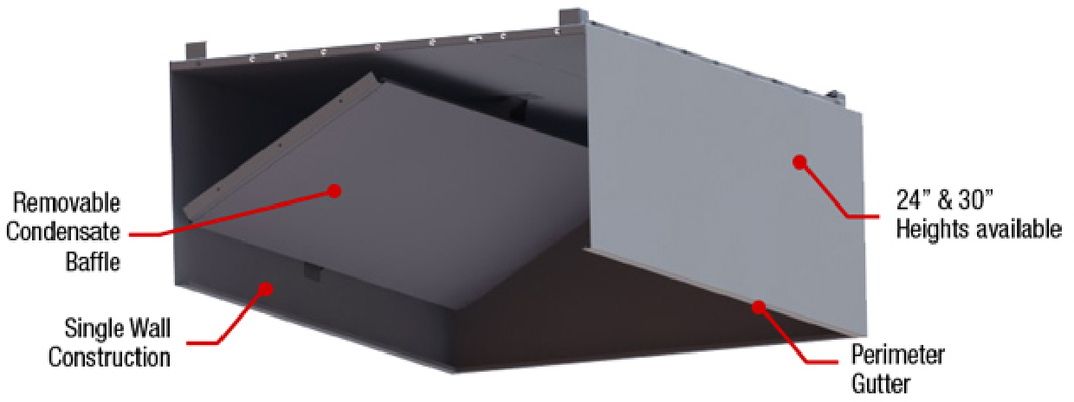

VHB Model with Two REM Baffles

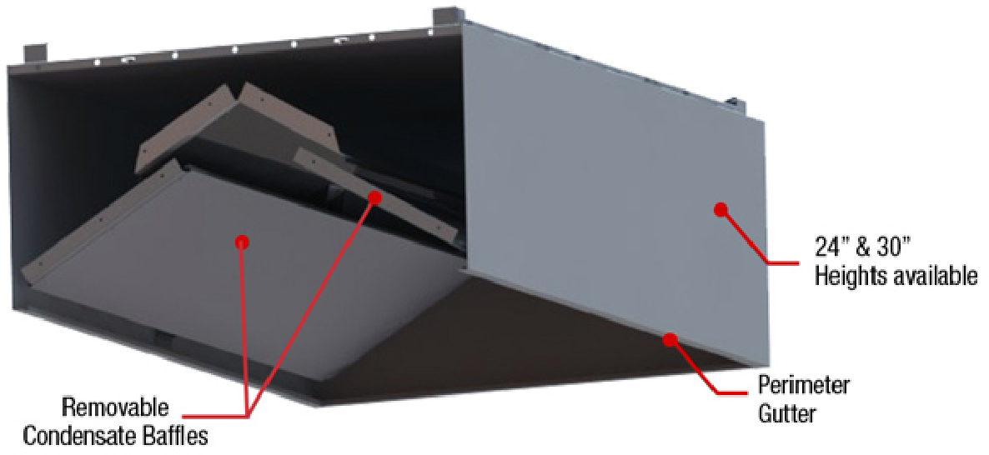

Certifications
The VHB Model has been certified by ITS. This certification mark indicates that the product has been tested to and has met the minimum requirements of a widely recognized (consensus) U.S. and Canadian products safety standard, that the manufacturing site has been audited, and that the applicant has agreed to a program of periodic factory follow­up inspections to verify continued performance.

Models VHB are ETL Listed under file number 3186625SAT­001 and complies with UL710, ULC710 and ULC­S646 Standards.

TO UTILITY TRANSFORMER
(
\
®

(j)
NEW CT CABINET AND SERVICE
3000A
) 3P '

NEMA 3R ENCLOSED SERVICE DISCONNECT
ON EXTERIOR OF BUILDING

NEW PANEL MDP2 (3000A, 3 PHASE, 4 WIRE, 480Y/277 VOLT)
3P 3P 3P 3P
PNL LTG1 I PNL LTG2

PROVIDE NEW PHONE LINE FOR ELEVATOR. PROVIDE 2 WAY COMMUNICATION SERVICE FOR COMMUNICATION. CONNECT TO NEW ELEVATOR PANEL. PROVIDE NEW PHONE LINE FOR DEDICATED COMMUNICATION

,

400A
) 3PNEW PNL H-HVAC

I

400A

400A
)3PNEW PNL
H-WLD2
I

200A
) 3P
I NEW PANEL H-CTL1

350A 350A 400A
) 3 ) 3P ) 3P NEW PNL
H-KTCH(HK)
350A
4 I

) 100A ) 100A

I

b) 100A ) 350A ) 250A &) 175A

) 400A ) 400A ) 400A ) 350A
I 3P 3P 3P 3P
I,
M1 (SECTION 1) I M2 (SECTION 1) I M3 (SECTION 1)

® Q)
)3PNEW PNL
H-WLD1
) 3P
@
NEW TRANSFORMER ECA:
(j) (j) ELEVATOR (j)
RTU-20 (D
® ®
M1 (SECTION 2) M2 (SECTION 2)
®
M3 (SECTION 2)
0w::::

v.J..v
_ rvYY"\ 22-5KVA BODA
© 3P

NEW PANEL EGAR 1
PROVIDE NEMA 3R DISCONNECT, TRANSFORMER AND PANEL ECAR AND LOCATE NEAR FLEET CHARGING APPROXIMATELY 150' FROM EDGE OF BUILDING.
PROVIDE STRUCTURE MOUNTING AND PADS FOR EQUIPMENT ©
® ® ®
PROVIDE A 250 AMP BREAKER IN MDP2 FOR SOLAR ARRAY
ow
© zU
1z-

NEW TRANSFORMER LDP1
I rvyv, 225KVA
BODA
) 3P

PROVIDE 2-80 AMP BREAKERS FOR PERSONAL CAR CHARGERS LOCATED AT PARKING CANOPY
NEW PANEL LDP1
100A
) 2P STORAGE
BLDING #1
I
100A
) 2P STORAGE
BLDING #2
DISCONNECT. COORDINATE WITH TRANE FOR SOLAR REQUIREMENTS. COORDINATE WITH SOLAR COMPANY TO PROVIDE 2-2" CONDUITS FROM FRONT CANOPY
TO PARKING CANOPY SOLAR ARRAY. PROVIDE 3-12"X 12" HAND HOLES FOR ROUTING AND ACCESS.
COORDINATE EXACT LOCATION WITH CIVIL
BUILDING APPROXIMATELY 100 FEET FROM BUILDING
<( z
0w:::: 0-
w
l-
o:::: u<(
<(

<i
z
Cl
Cl:'.
>
.

200A
)3p NEW PNL L-ENG1

NEW PNL

400A
200A
) 3P NEW PNL ) 3P NEW PNL L-KTCH1 L-HMS

NEW PNL

200A
)3p NEW PNL LG1

200A
)3p NEW PNL L-ADMIN

) 3P NEW PNL I ) 2P I 2P L-LAND
COORDINATE EXACT LOCATION WITH CIVIL BUILDING APPROXIMATELY
200A
BOA ) BOA

NEW TRANSFORMER LDP2 225KVA

NEW TRANSFORMER LDP3 225 KVA NEMA 3R

rv-yv-'l

u::)
0:::: 0
zWW

w
'cc:
0z
<i 0 Cl:'.

L-ENG2
E""T
L-KTCH2

200A
45 FEET FROM BUILDING

200A

200A
BODA
) 3P

200A

200A

NEW PANEL LDP2 BOOAMPS, 3 PHASE, 4 WIRE

200A

200A

BODA
©
_J
LL <(
u
LL

)3NEW PNL L-SM
) 3P NEW PNL
L-SS2
)3p NEW PNL
I L-TV1

NEW PNL L-TV2
)3p NEW PNL
I L-BB1

NEW PNL L-BB2
) 3P
I NEW

N

PNL L-COS1
)3p NEW PNL L-BIT3
) 3P
I NEW

PNL L-BIT1L

L L-BIT2
) 3P

©
::)
0::::
z
:r:
u

w
I-

ATE TRANSFORMER LDP3 ON THE EXTERIOR OF THE BUILDING PROVIDE ENCLOSED CIRCUIT BREAKER OR FUSES DISCONNECT SECONDARY SIDE OF TRANSFORMER TO FEED PANEL LDP3

BODA

PANEL LDP3 BOOAMPS, 3 PHASE, 4 WIRE
"-.._A_./
) 3P

100A
) 2P ELEVATOR PANEL

200A
1) 3P NEW PANEL L-MTL1

200A
)3p NEW PNL I L-ATP1

400A
1)3P NEW PNL
L--lVAC1

200A
) 3P
I NEW PANEL L-CTL1

400A
) 3P NEW PNL
I
L-WLD1

400A
)3p NEW PNL
j L-WLD2

l
B NEW PANEL
L-MTL2

NEW PNL L-ATP2

NEW PNL L-HVAC2

NEW
® ®
PANEL L-CTL2

GAs SERVICE a

- EXISTING BUILDING STEEL
PROVIDE 100 AMP, ELEVATOR EQUIPMENT PANEL TO PROVIDE POWER FOR ELEVATOR RECEPTACLE, SUMP PUMP, LIGHTING AND
AIR CONDITIONER. LOCATE PANEL INSIDE ELEVATOR EQUIPMENT ROOM. COORDINATE WITH ELEVATOR INSTALLER
FEEDER SCHEDULE
(J) | WIRESIZE
1 | 4-#3, 1-#8G,11/4"C
2 | 4-2/0, 1-#4G, 2"C
3 | 4-#3/0, 1-#4G, 2 1/2"C
4 | 3-#500MCM, 1-#3G, 3"C
5 | 2 SETS( 4-#3/0, 1-#3G, 2 1/2"C)
6 | 3 SETS( 4-300MCM, 1-#1/OG, 3"C)
7 | B SETS( 4-500MCM, 1-400G, 4"C)
B | 3-#3, 1-#BG, 1-1/4"C
9 | B SETS( 4-500MCM, 4"C) 1 SPARE 4"

REVISIONS
No. | DATE | DESCRIPTION
1 | 07/18/22 | ADDENDUM 3
2 | 07/29/22 | ADDENDUM 5
DRAWN BY: |  |  | DWG
REV'D BY: |  |  | DWG
DATE: |  |  | 06/17/2022
SCALE: |  |  | AS SHOWN
ELECTRICAL ONE LINE NEW WORK PLAN
E-501
SHEET X of X

METAL STAIR
1
a i a
FOR REQUIREMENTS. PROVIDE DISCONNECT FOR ELEVATOR CAB LIGHTING AND PROVIDE PHONE LINE

1 6
TRANSFORMER SCHEDULE
NAME: | SIZE: | PRIMARY VOLT | SECONDARY VOLT
XFMR LDP1 | 225 KVA | 480 DELTA | 20BY/120
XFMR LDP2 | 225 KVA | 480 DELTA | 20BY/120
XFMR LDP3 | 225 KVA | 480 DELTA | 20BY/120
XFMR EGAR | 225 KVA | 480 DELTA | 20BY/120

NEW ELECTRICAL SERVICE ONE LINE DIAGRAMS

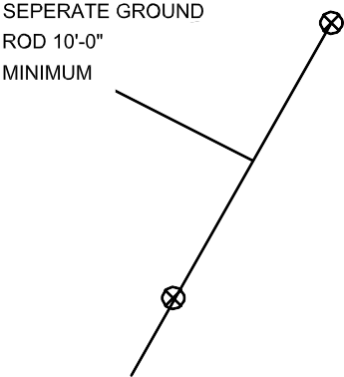
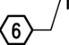
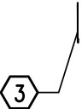
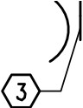
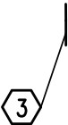
#310 IN 1"C SPRINKLER
NEW WORK ONE-LINE LEGEND
,.-.._
NEW CIRCUIT BREAKER
PANELBOARD FEEDER
-'-
GROUNDING

GROUND BAR-----.. IN SERVER ROOM '-
-

I a
#310 IN 1"C
GROUND BUS IN SERVICE DISCONNECT
,
/ #310 IN 1" C.

GROUNDING DETAIL

D 10'-0"

NEW WORK NOTES
1. PROVIDE NEW ELECTRICAL SERVICE INDICATED

8' 0
2100 LUBNA DR
CHRISTIANSBURG VA 24073
P. 540.998.6069
1/e"-1'-o·---

8 16

Q::'.

w
z
1-

ow
)

zU
<( z
Qw::'. 0-
w
I-
Q::'. <(
u
<u( ::)
Q::'. 0

WW
z
_J
LL <(
u
LL

<(
z
Cl
O:'.
>
w.
'cc:
0z
<(
0
O:'.

::)
Q::'.
z

:r:
u

w
I-

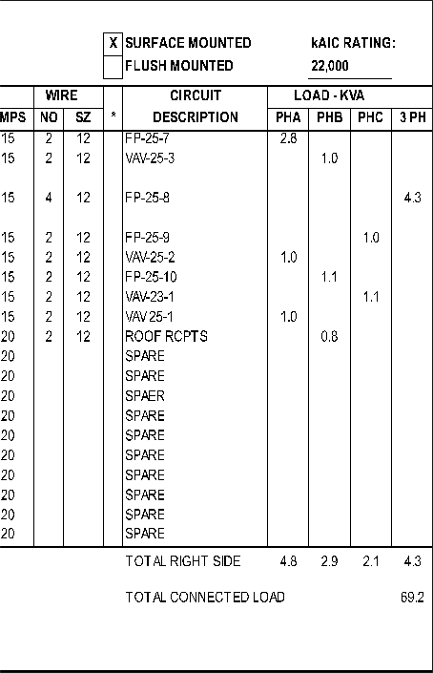
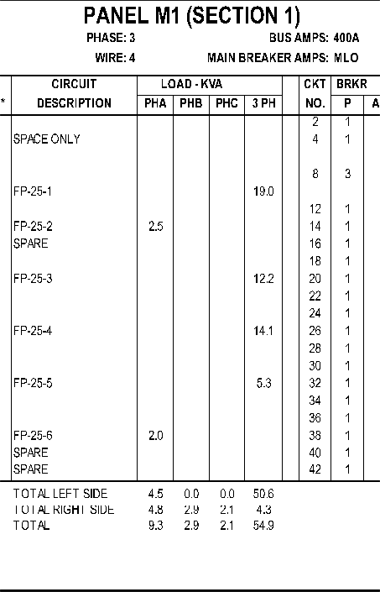
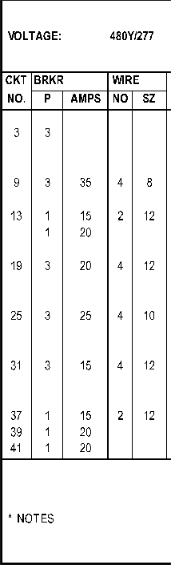
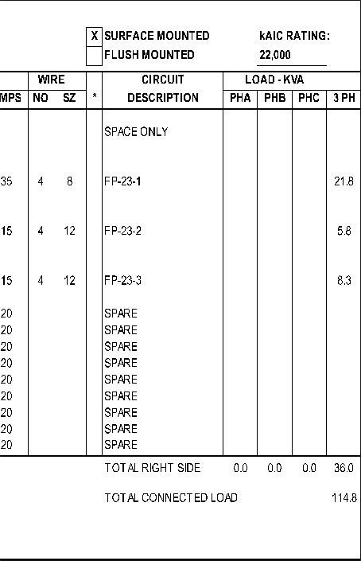
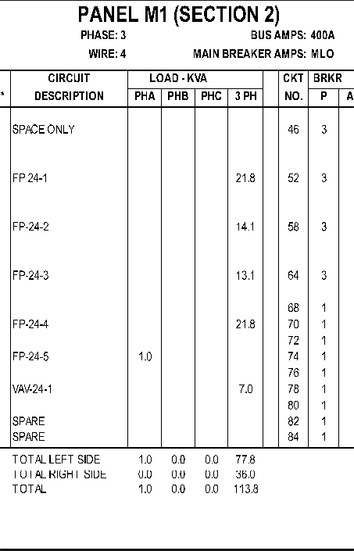
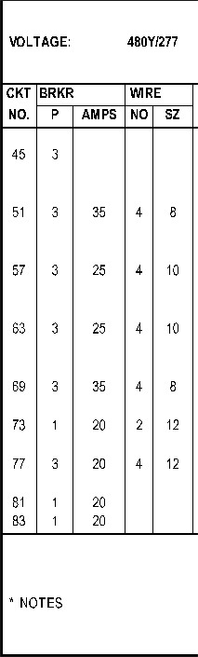
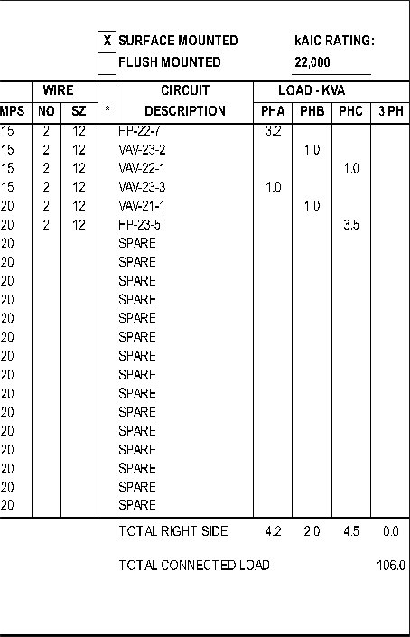
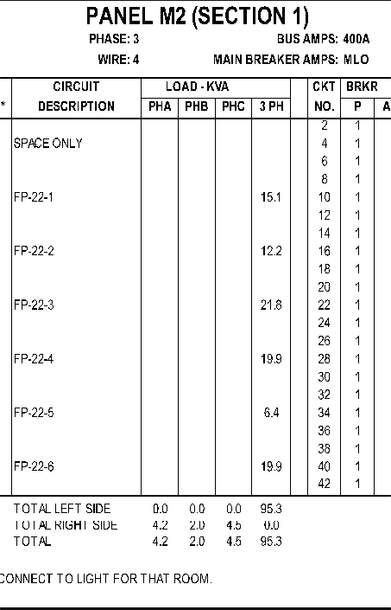
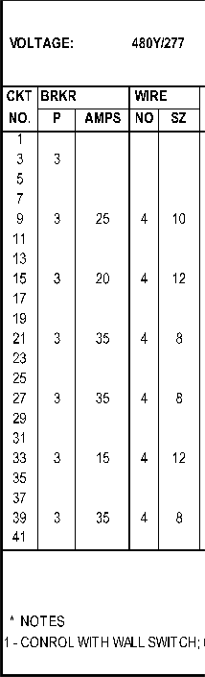
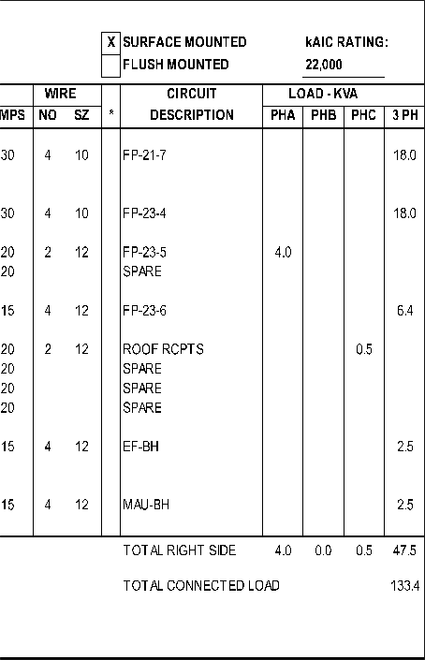
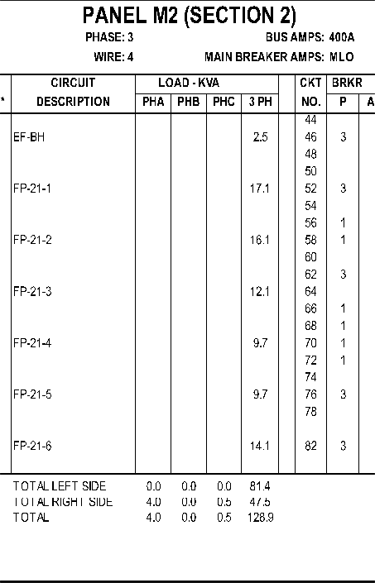
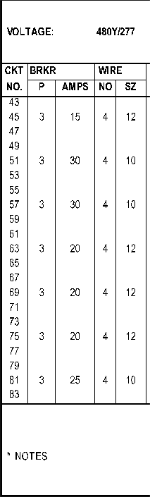
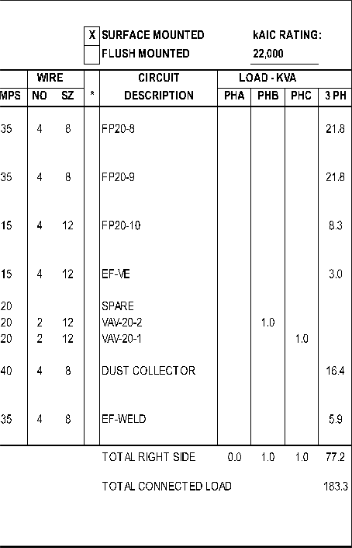
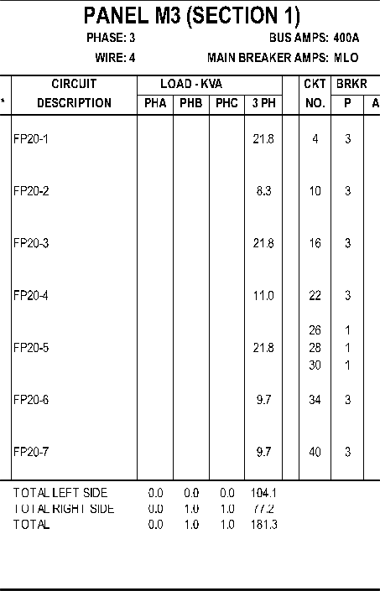
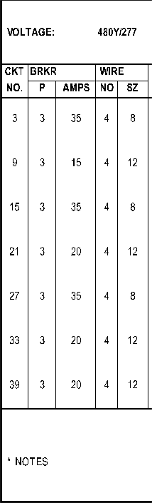
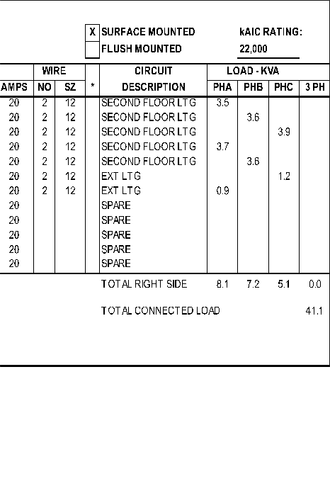
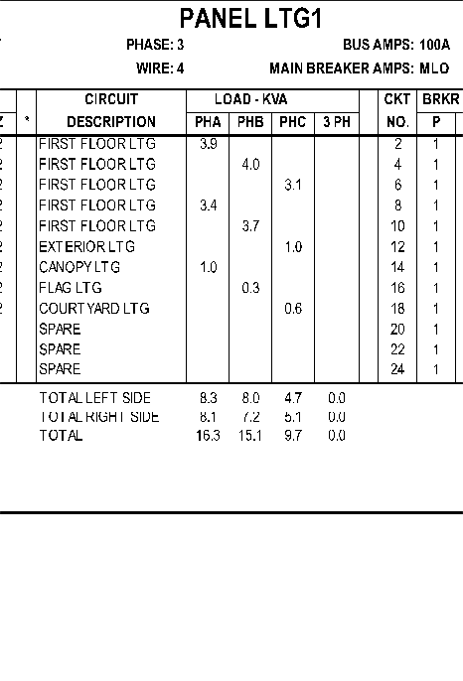
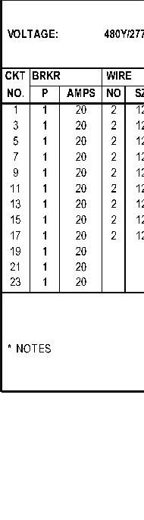
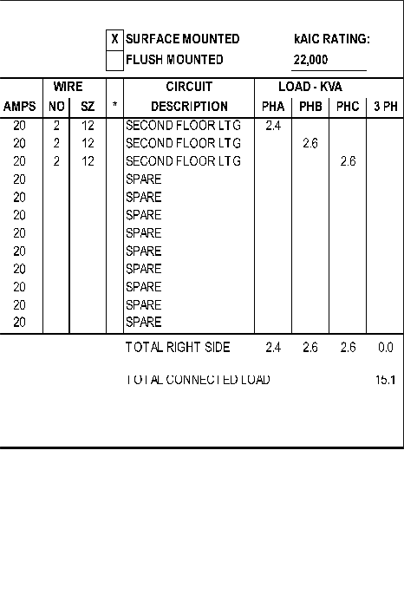
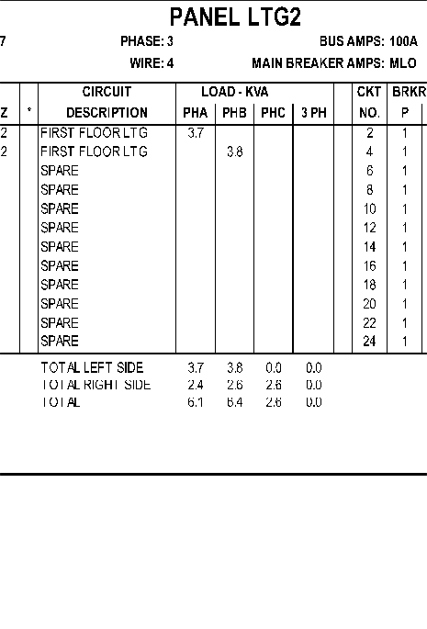
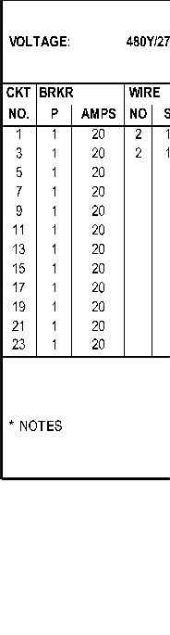
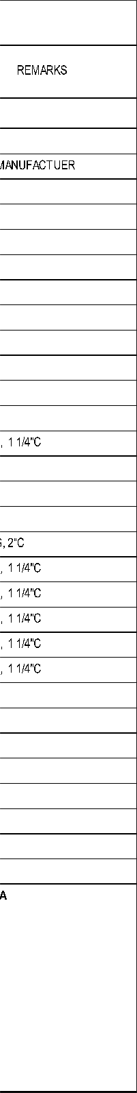
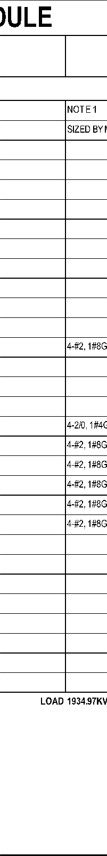
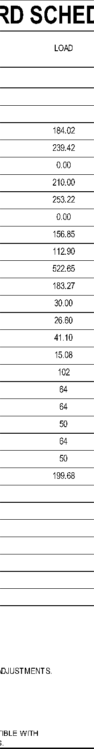
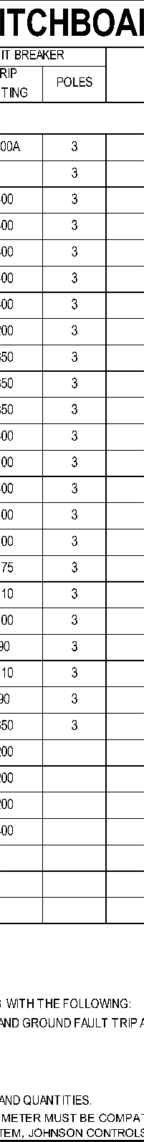
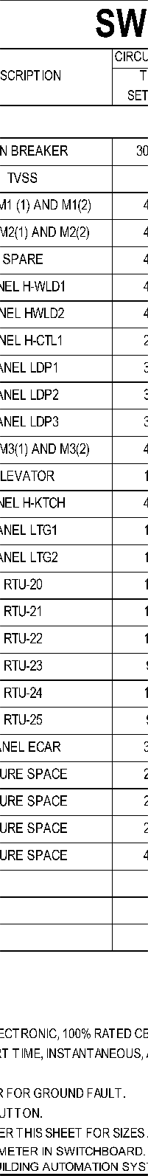
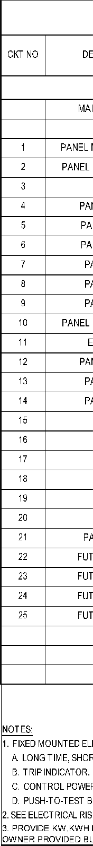
'-. /'-. /

1 -1 -0

2100 LUBNA DR
CHRISTIANSBURG VA 24073
REVISIONS
No. | DATE | DESCRIPTION
 | 07/18/22 | ADDENDUM 3
2 | 07/29/22 | ADDENDUM 5
DRAWN BY:  '□ |  |  | DWG
REV BY: |  |  | DWG
DATE: |  |  | 06/17/2022
SCALE: |  |  | AS SHOWN
PANEL SCHEDULES
E-502
SHEET X of X

P. 540.998.6069

16

,,,----- ,_

'-.._/
Q::'.

w
z
1-

ow

zU
<( z
Qw::'. 0-
w
I-
Q::'. <(
u
<u( ::)
Q::'. 0

WW
z
_J
LL <(
u
LL

<(
z
Cl
O:'.
>
.
w 'cc: 0z
<(
0
O:'.

::)
Q::'.
z

:r:
u

w
I-

&
)
REVISIONS
No. | DATE | DESCRIPTION
 | 07/18/22 | ADDENDUM 3
2 | 07/29/22 | ADDENDUM 5
DRAWN BY:  '□ |  |  | DWG
REV BY: |  |  | DWG
DATE: |  |  | 06/17/2022
SCALE: |  |  | AS SHOWN
PANEL SCHEDULES
E-503
SHEET X of X

'-.._/

)

'-.. /

2100 LUBNA DR
CHRISTIANSBURG VA 24073
P. 540.998.6069

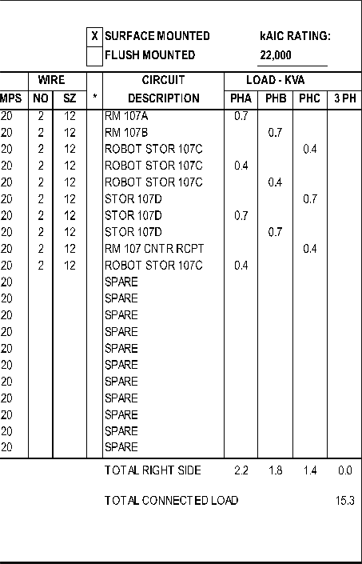
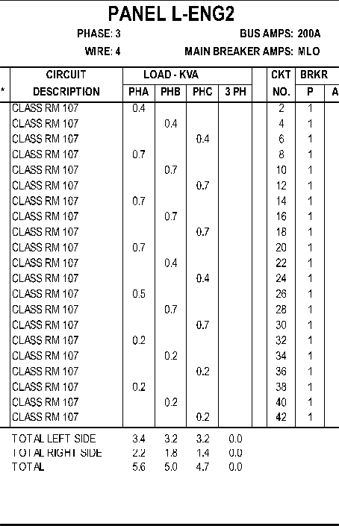
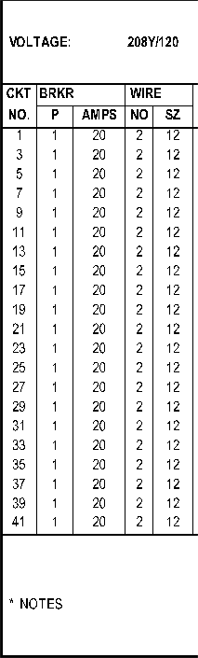
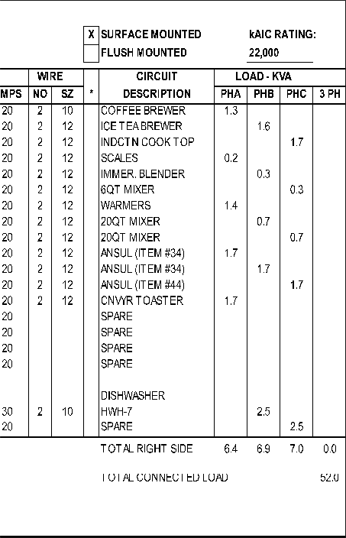
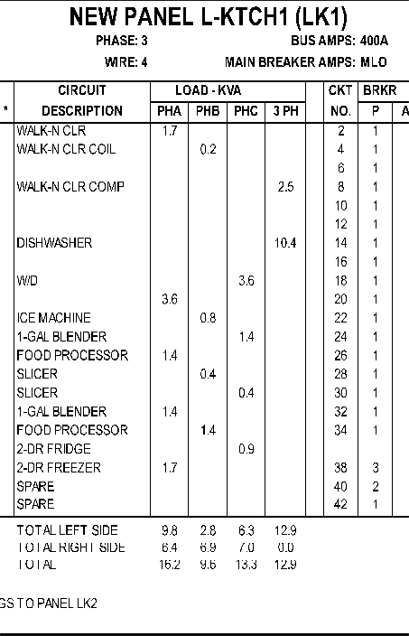
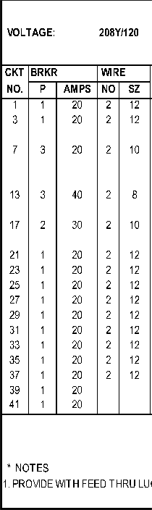
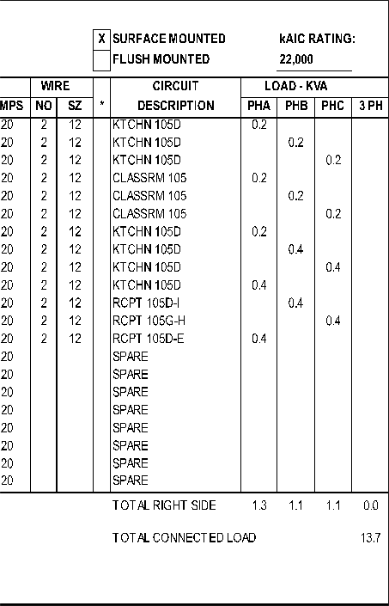
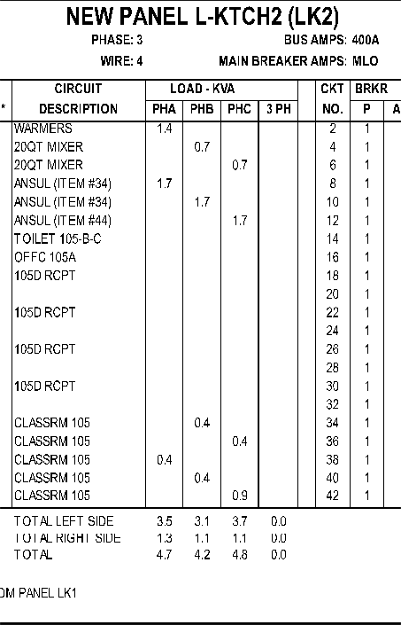
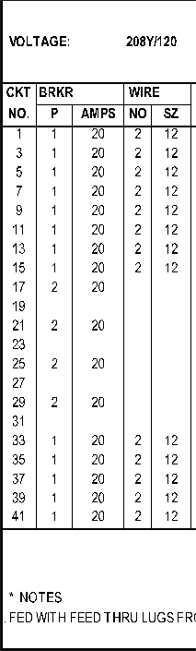
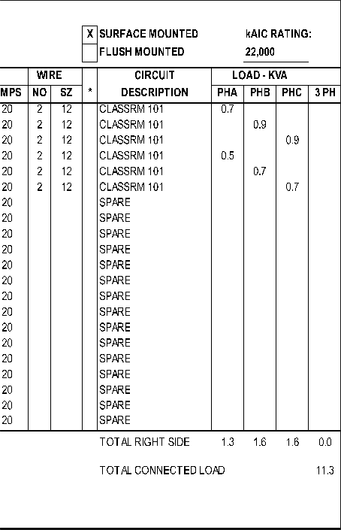
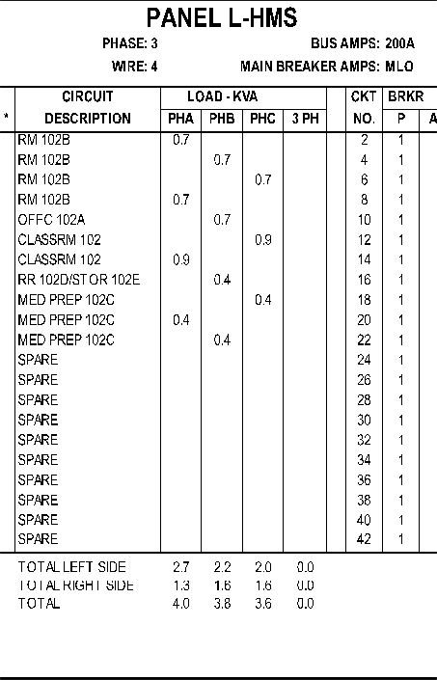
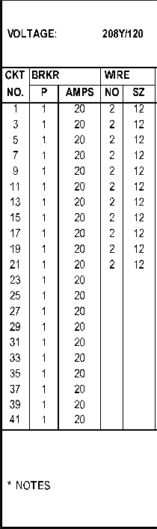
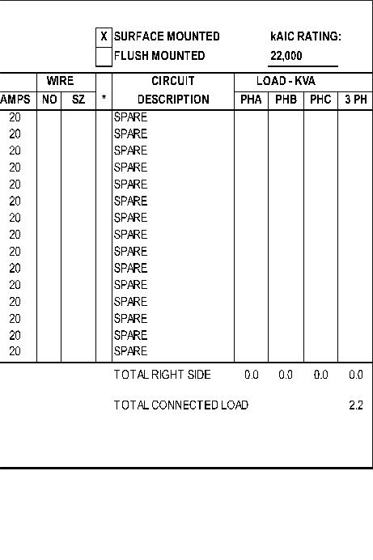
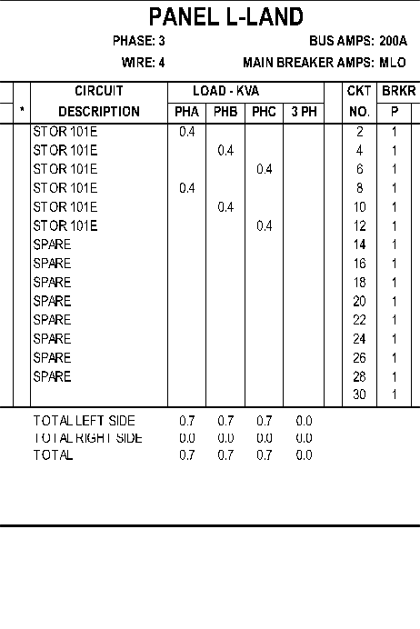
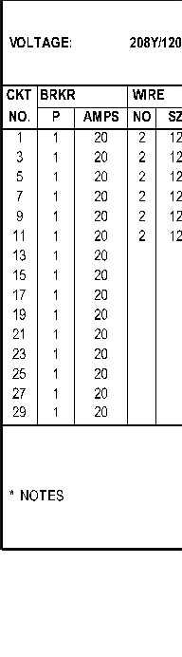
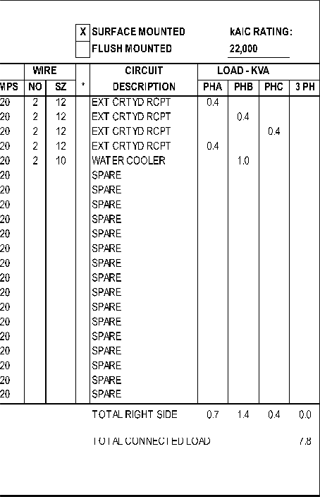
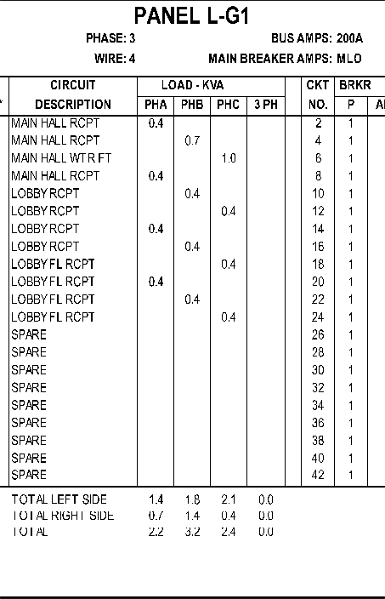
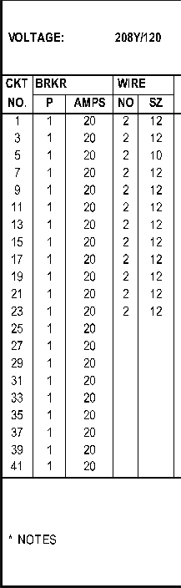
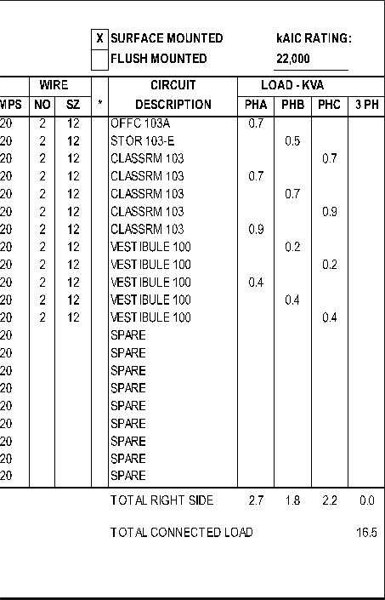
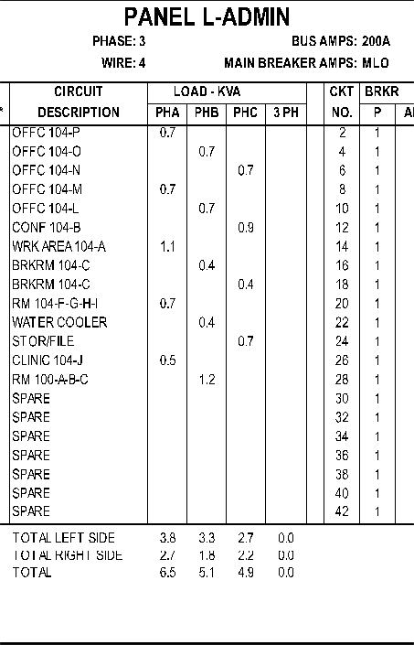
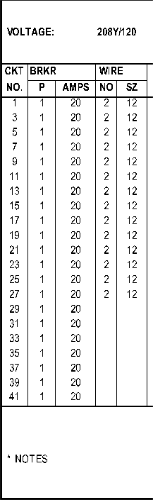
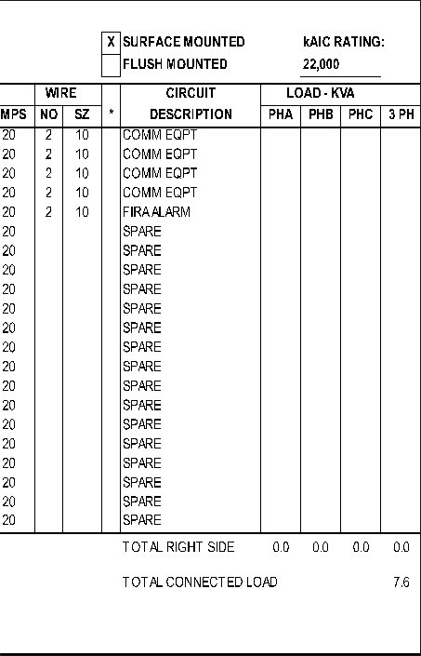
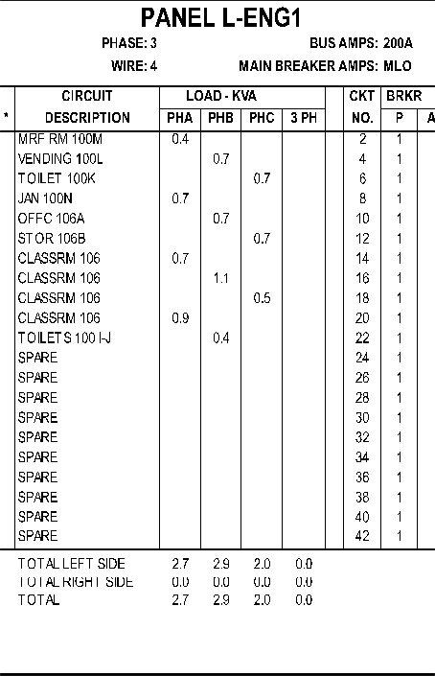
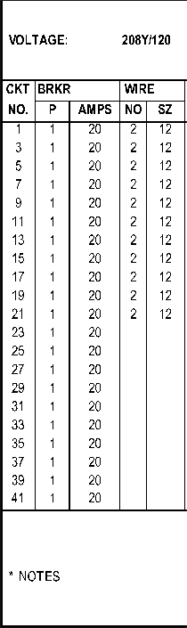
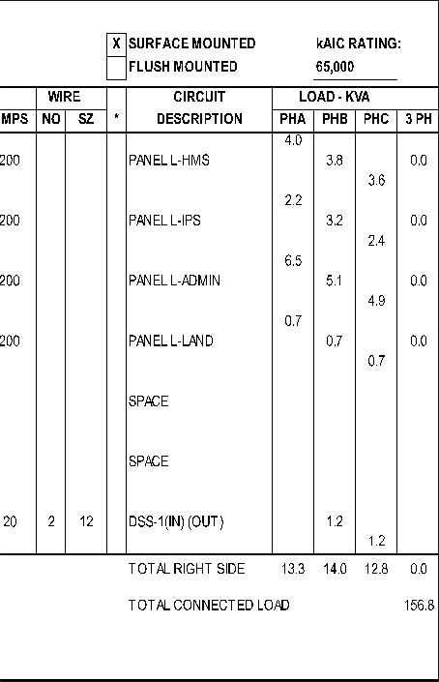
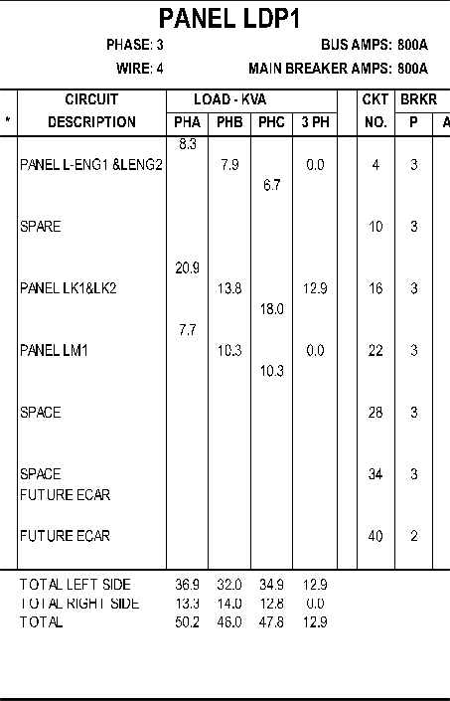
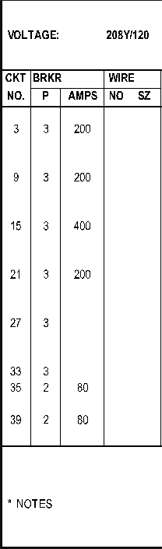
8' 0
1/s"-1'-o·---
8 16

'-. /
Q::'.
w
1-
z

ow

zU

<( z
Qw::­'. 0
w
I-
Q::'. <(

<(
z
Cl 0::

u<( :u:)
>
w-
'-c
0z

Q::'. 0
WW
z
_J
LL <(
u
LL

<(
0
0::

::)
Q::'.
z

:r:
u
w
I-

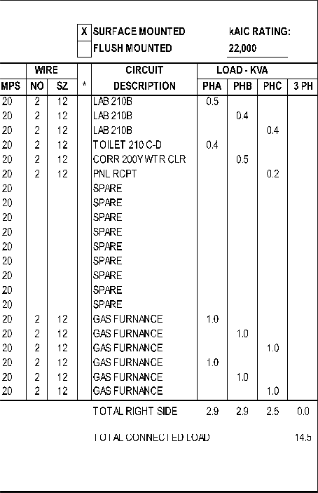
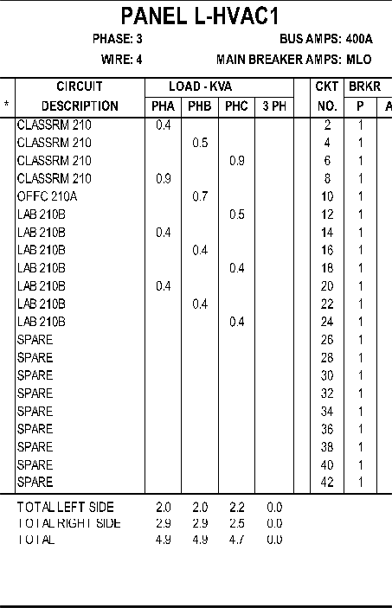
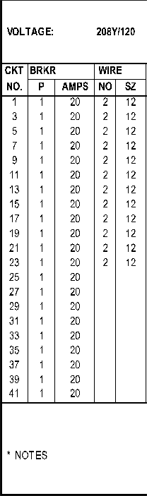
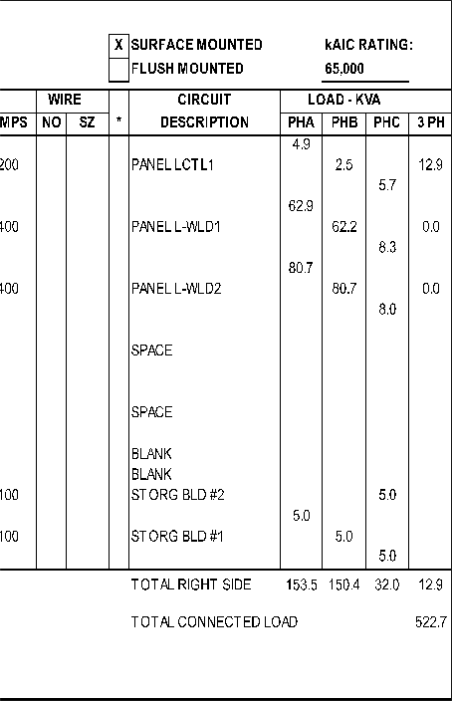
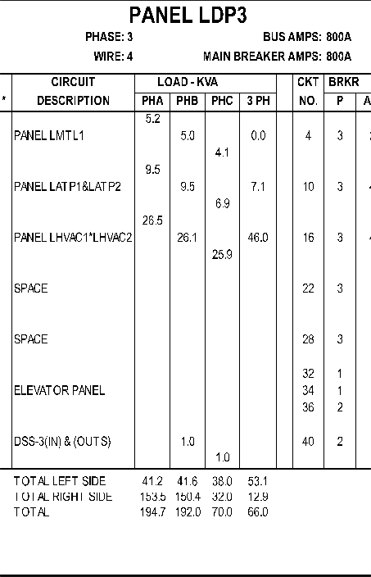
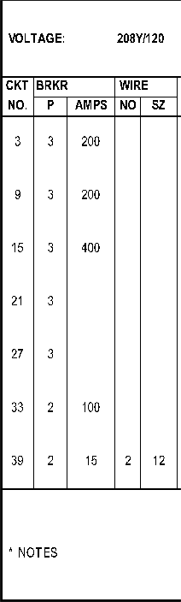
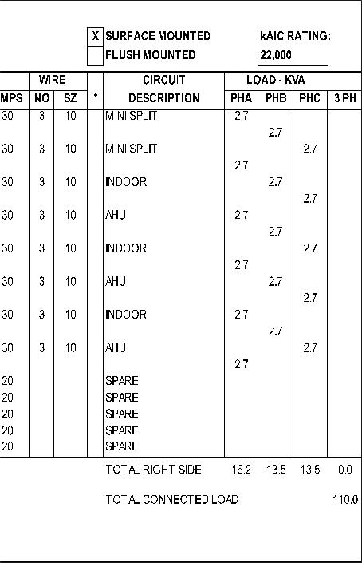
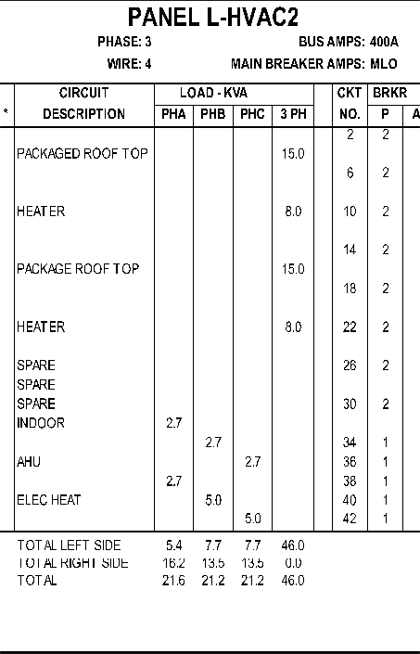
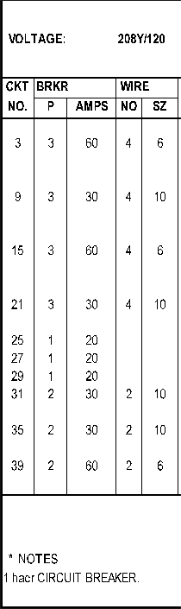
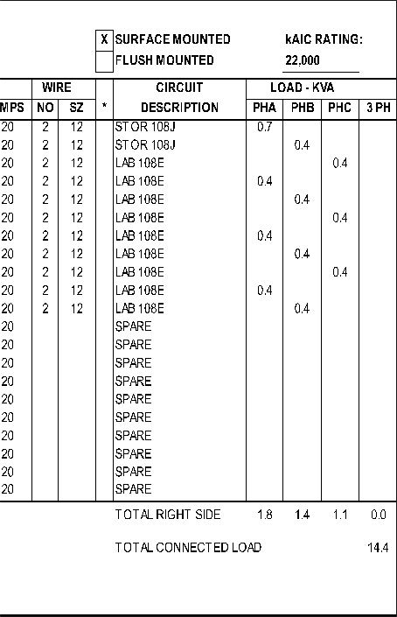
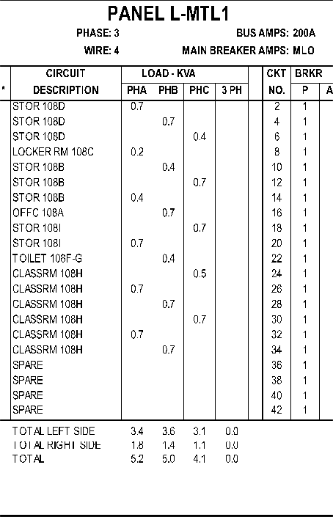
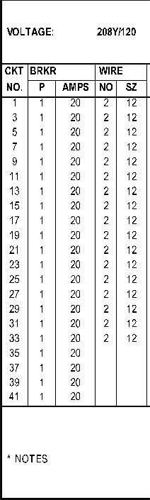
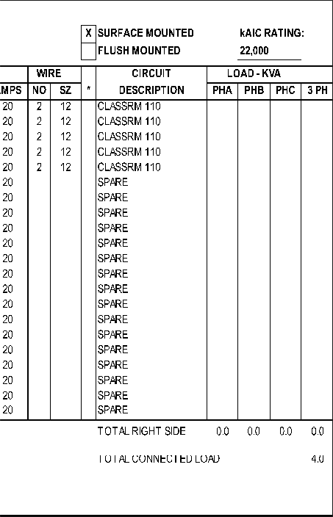
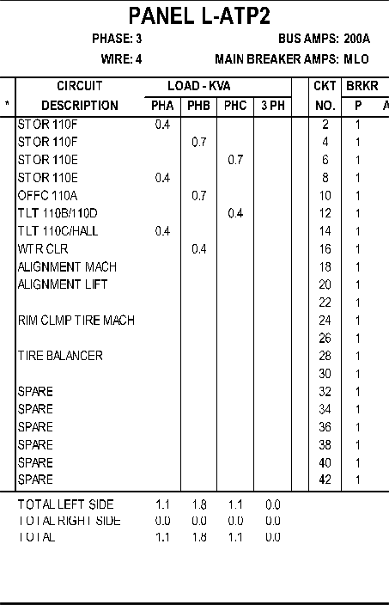
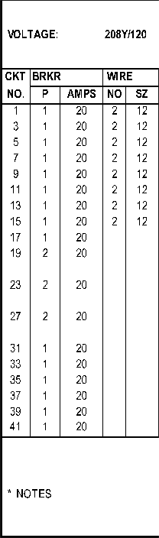
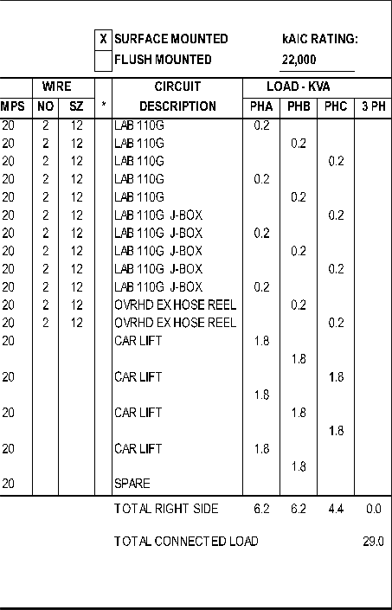
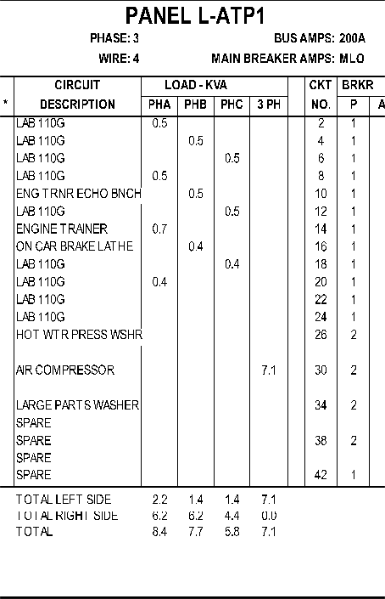
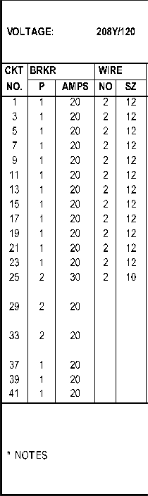
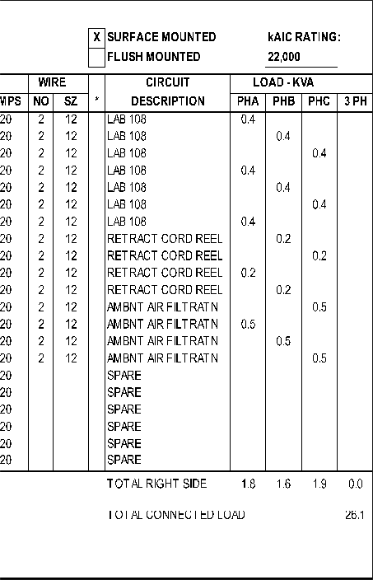
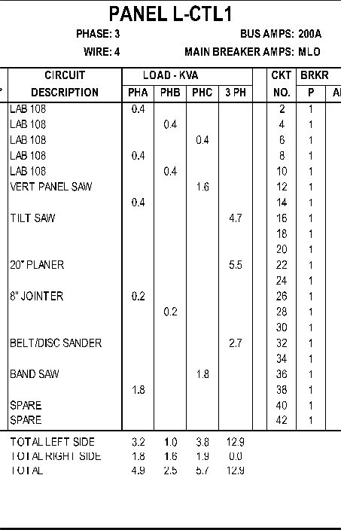
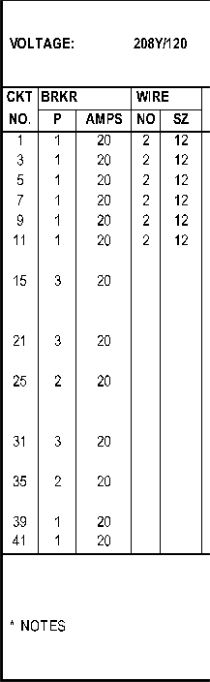
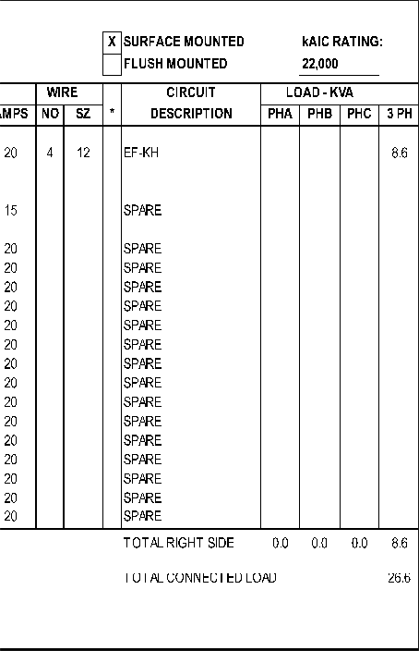
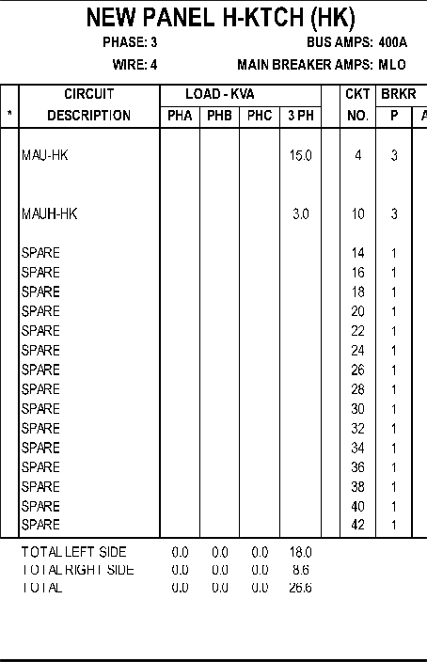
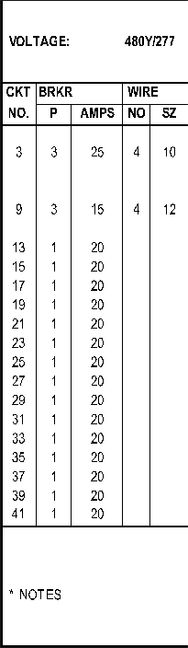

'--._/ '-. /
)

&
REVISIONS
No. | DATE | DESCRIPTION
 | 07/18/22 | ADDENDUM 3
2 | 07/29/22 | ADDENDUM 5
DRAWN BY: |  |  | DWG
REV'D BY: |  |  | DWG
DATE: |  |  | 06/17/2022
SCALE: |  |  | AS SHOWN
PANEL SCHEDULES
E-506
SHEET X of X

2100 LUBNA DR
CHRISTIANSBURG VA 24073
P. 540.998.6069

va·-1·-o·---
8' 0 8
16

)

)

'-.. / '-.. /
Q::'.

w
z
1-

ow

zU
<( z
Qw::'. 0-
w
I-
Q::'. <(
u
<u( ::)
Q::'. 0

WW
z
_J
u
LL <(
LL

<(
z
Cl
O:'.
>
w.
'cc:
0z
<(
0
O:'.

::)
Q::'.
z

:r:
u

w
I-

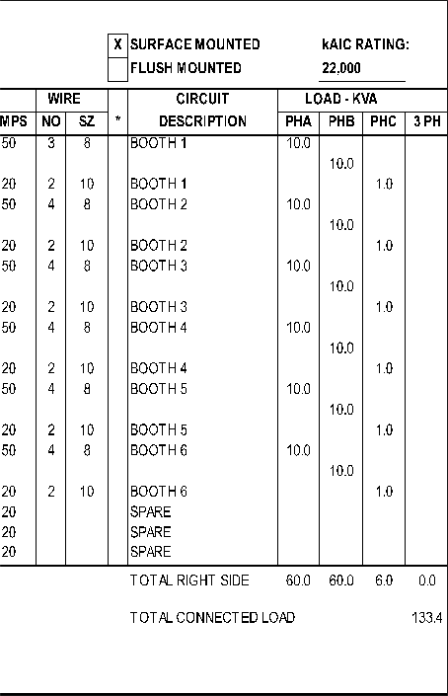
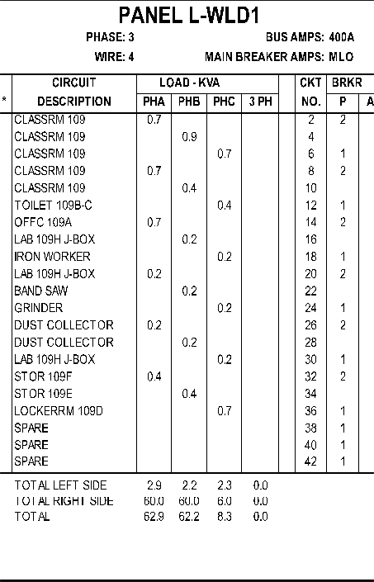
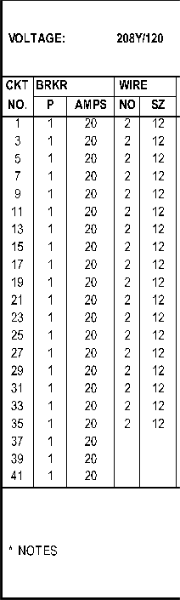
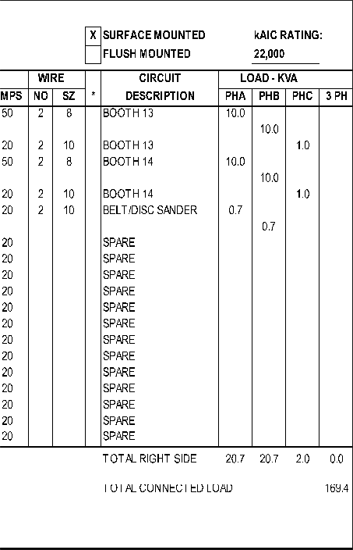
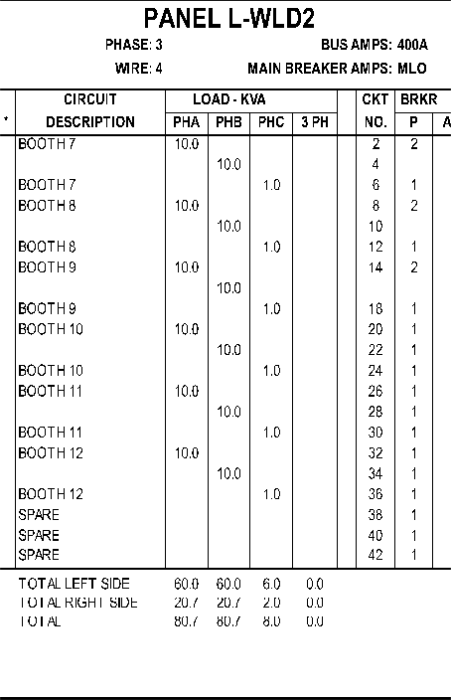
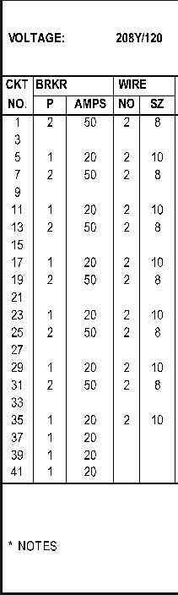

11e·-1·-o·
&,

2100 LUBNA DR
REVISIONS
No. | DATE | DESCRIPTION
 | 07/18/22 | ADDENDUM 3
2 | 07/29/22 | ADDENDUM 5
DRAWN BY:  '□ |  |  | DWG
REV BY: |  |  | DWG
DATE: |  |  | 06/17/2022
SCALE: |  |  | AS SHOWN
PANEL SCHEDULES
E-507
SHEET X of X

CHRISTIANSBURG VA 24073
P. 540.998.6069

16

)

) )

'--. ,A /
Q::'.

w
z
1-

ow

zU

<( z
Qw::'. 0-
w
I-
Q::'. <(
u
<u( ::)
Q::'. 0

WW
z
_J
u
LL <(
LL

<(
z
Cl
O:'.
>
w.
'cc:
0z
<(
0
O:'.

::)
Q::'.
z

:r:
u

w
I-

2100 LUBNA DR
REVISIONS
No. | DATE | DESCRIPTION
 | 07/18/22 | ADDENDUM 3
2 | 07/29/22 | ADDENDUM 5
DRAWN BY:  '□ |  |  | DWG
REV BY: |  |  | DWG
DATE: |  |  | 06/17/2022
SCALE: |  |  | AS SHOWN
PANEL SCHEDULES
E-508
SHEET X of X

CHRISTIANSBURG VA 24073
P. 540.998.6069

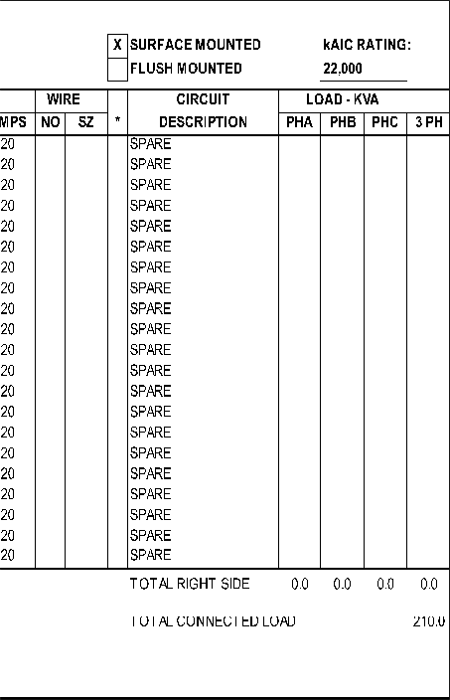
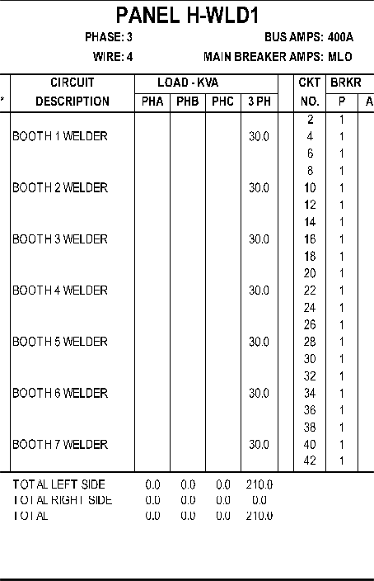
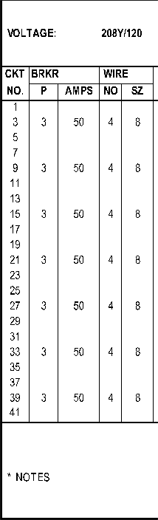
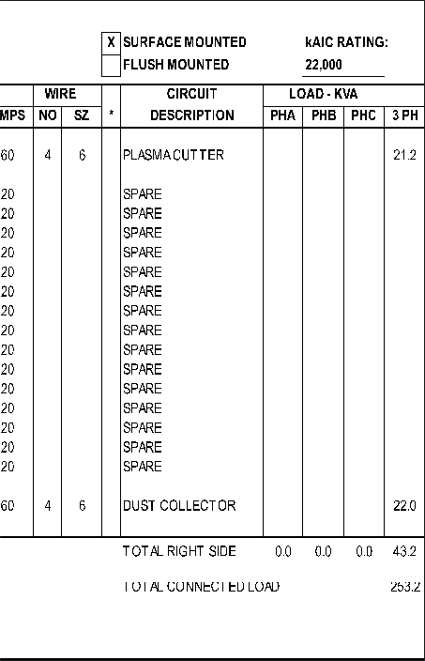
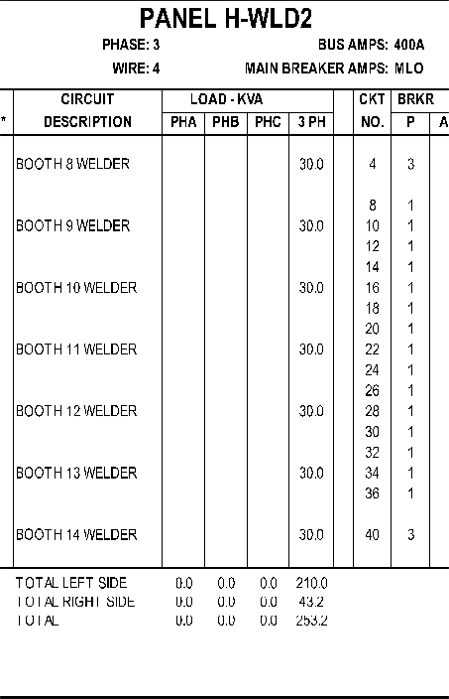
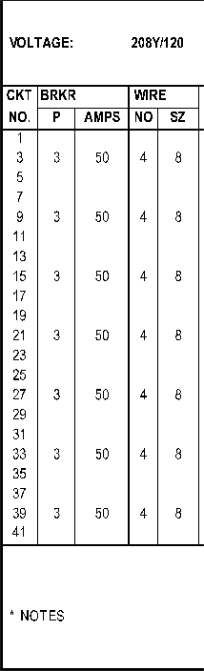
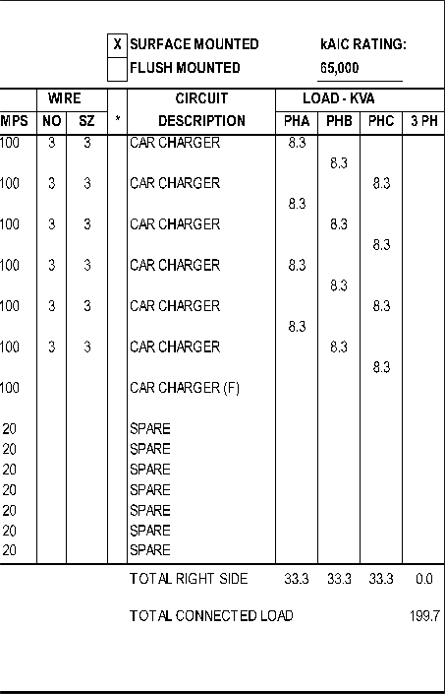
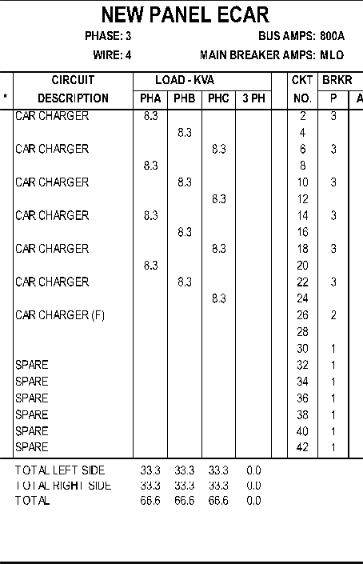
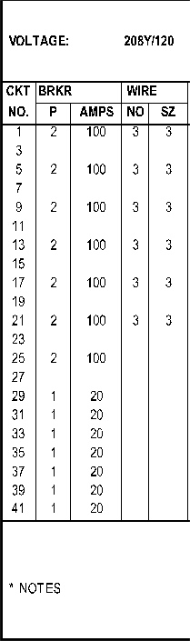
'-._/

8' 16
1/s"-1'-o·---

